

|  |
| --- |
| **CLEVO - a budding sharemarket investor application**  **Tools - research material** |



**Laravel research and instructions** by Evan and Lucas

* open-source PHP framework for rapid development
* Uses composer to manage all dependencies and ensures they are up to date
* has powerful commandline functions that allow for easy setup (eg. php artisan make:auth = makes login and registration views)
* fully supports the MVC design pattern in the PHP environment
* allows for easy addition of other third party frameworks that can also be managed through the composer application
* built in support for SQL rational databases
* built in URL routing features for loading new views and controllers
* very easy to set up and start development

Instructions from

<https://laravel.com/docs/5.3/installation>

<https://stackoverflow.com/questions/25610958/installing-laravel-on-existing-project>

1. Download and install Composer. [https://getcomposer.org/download](https://getcomposer.org/download/)
2. Add the Composer path to your system’s environment variables. This will vary

between systems. On Windows 10 it was *C:\Users/USERNAME\AppData\Roaming\Composer\vendor\bin*

Once you know this path add it to your environment variables.

System Properties > Advanced > Environment Variables > Path

1. Open cmd and run -

composer global require "laravel/installer"

1. You need to clone the BitBucket repository to a new folder. If you are using XAMPP for your local web server then do this to the htdocs folder. I recommend naming this folder *clevo-rmit* so we are all using the same name.
2. In CMD navigate to this folder.

cd c:/xampp/htdocs/clevo-rmit

1. Run the following command

composer update

OR

composer install

1. With XAMPP running you should now be able to see a Laravel landing page at http://localhost/clevo-rmit/public/

**Research Market Finance API** by Carlo

* Yahoo! Finance API seems to be our best option
* Quandl only provides static historical data and so is not appropriate for our task
* Google finance appears to be deprecated
* Can return XML, JSON or CSV
* Free to use
* Huge amount of information can be retrieved
* Short delay of about 15 minutes which shouldn’t matter for our purposes
* Yahoo! Finance API is REST based, will basically involve adding stock symbols and parameters to the base URL to retrieve the relevant data.

|  |  |  |  |  |
| --- | --- | --- | --- | --- |
| Australia | Australian Stock Exchange | .AX | 20 min | Interactive Data Real-Time Services |

* <http://www.jarloo.com/yahoo_finance/>
* This is specifically for CSV but I think we would grab JSON objects and parse them in PHP.

**Leantest research** by Ocal

* Allows users to create project
* Allows users invite team members
* Allows for multiple account managers
* Connects with slack and bitbucket
* Allows for bug reporting via app
* Allows for attachments of documents, screenshots etc
* Allows for the severity and priority of bug to be reported
* Allows for selenium IDE testing of HTML only avaliable through Mozilla
* Allows for overview of all bugs reported and completed during duration of project
* Allows for conversation between team
* Easy to navigate
* Leantest allows users to have a visual representation of the progress of the project whilst still keeping communication channels open.
* Lean Test <https://leantesting.com/>
* Demo <https://www.youtube.com/watch?v=BqoLn2Gctaw>

**PHPUnit research and instructions** by Vio

PHPUnit is a programmer-oriented testing framework for PHP.  
It is an instance of the xUnit architecture for unit testing frameworks.

Download from: <https://phar.phpunit.de/phpunit.phar>

Setup instructions: <https://phpunit.de/manual/current/en/installation.html#installation.composer>

Instructions from the link above:

### **Windows**

Globally installing the PHAR involves the same procedure as manually [installing Composer on Windows](https://getcomposer.org/doc/00-intro.md#installation-windows):

1. Create a directory for PHP binaries; e.g., C:\bin
2. Append **;C:\bin** to your PATH environment variable ([related help](http://stackoverflow.com/questions/6318156/adding-python-path-on-windows-7))
3. Download <https://phar.phpunit.de/phpunit.phar> and save the file as C:\bin\phpunit.phar
4. Open a command line (e.g., press **Windows**+**R** » type **cmd** » **ENTER**)
5. Create a wrapping batch script (results in C:\bin\phpunit.cmd):

C:\Users\username> cd C:\bin

1. C:\bin> echo @php "%~dp0phpunit.phar" %* > phpunit.cmd
2. C:\bin> exit
3. Open a new command line and confirm that you can execute PHPUnit from any path:
4. C:\Users\username> phpunit --version
5. PHPUnit x.y.z by Sebastian Bergmann and contributors.

For Cygwin and/or MingW32 (e.g., TortoiseGit) shell environments, you may skip step 5. above, simply save the file as phpunit (without .phar extension), and make it executable via **chmod 775 phpunit**.

Other useful links:  <https://www.youtube.com/watch?v=-9YVcssCACI>

Oficial website: <https://phpunit.de/>

**JMeter Testing** - by Ocal

JMeter is an open source testing tool its primary purpose is to execute a load test and stress test scripts. JMeter simulates a group of users sending requests to a target server, and returns statistics that show the performance/functionality of the target server/application via tables, graphs and log report. Load tests performed by JMeter helps you understand response time, users it can support, load at which it breaks, CPU memory usage, memory leaks, accuracy and page load issues.

Some of the key features of JMeter are:

* Can run on any operating system
* Various assertions to define criteria
* Multiple built in and external listeners to visualize and analyse performance test results and determine where errors occur
* Multi protocol support
* Jmeter can perform test as development is integrated, can be part of the full software development lifecycle
* Easy to understand GUI
* JMeter can stimulate what are browser does

To execute a test via JMeter, add elements to the test plan, add a thread group, add timer, add the server that you wish to hit and then view results in table or graph format. The main attraction of JMeter is when a test is executed it will not stop and will continue with the test script, only displaying errors once it has finished or test had been stopped.

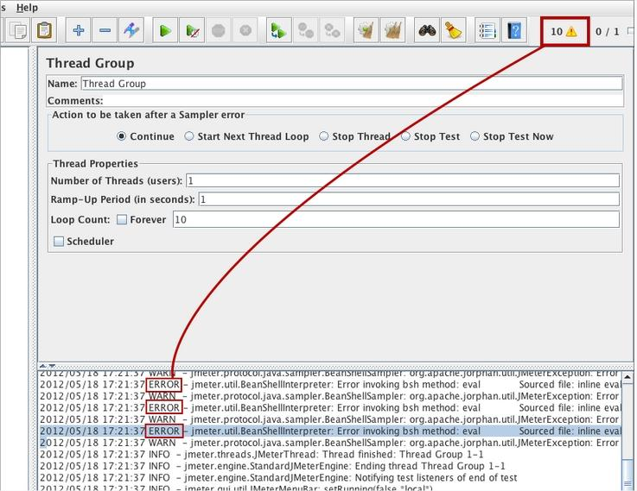

Sample test Image